MINOR PROPHETS #1: INTRODUCTION (7-20-14)
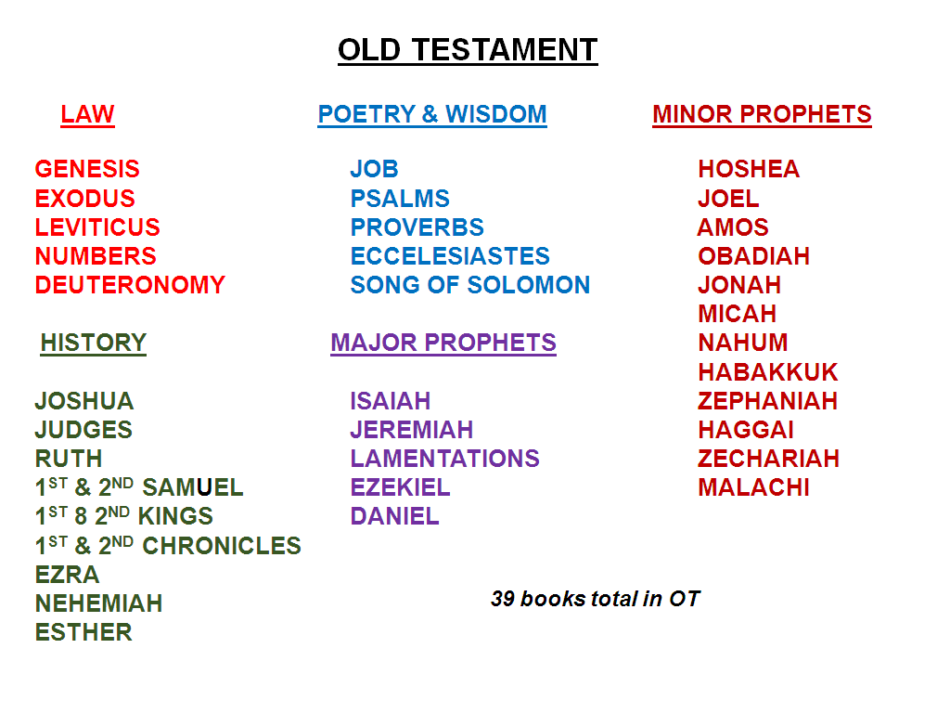
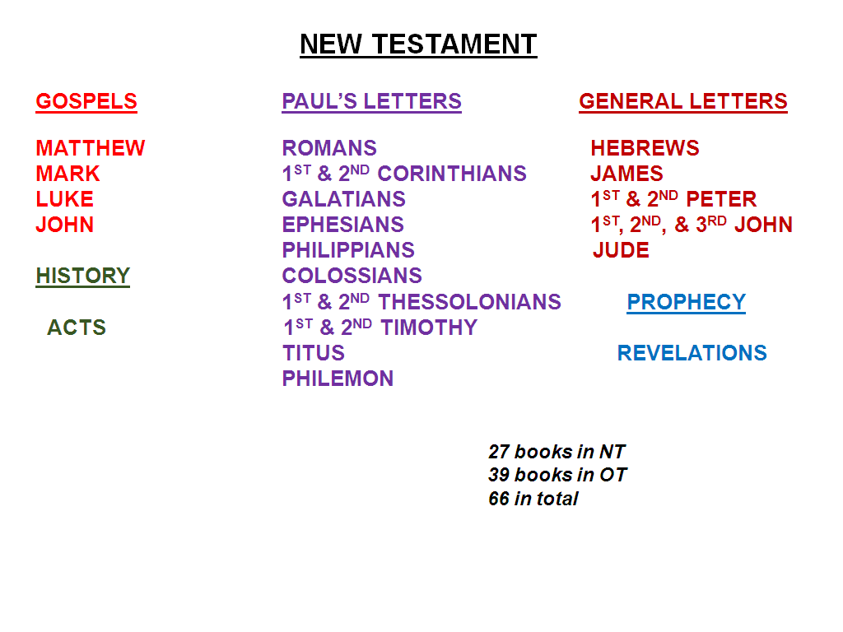
39 books in OT
27 books in NT
66 books total

GENESIS
Creation, the Fall, the Flood, Abraham, Isaac, Jacob (Israel), the twelve tribes of Israel, Joseph in Egypt
EXODUS 1450-1410 BC; Israelites in Bondage, Moses, the Exodus, the 10 Commandments & the Mosaic Law given.
LEVITICUS 1450-1410 BC; Instructions on sacrifice and laws concerning everyday life.
NUMBERS 1450-1410 BC; Israel’s wonderings in the wilderness.
DEUTERONOMY 1410 BC; Final month of Moses before Israelites crossed over to Canaan.
JOSHUA 1400 -1370 BC; Conquest of Canaan & the dividing the land to the various tribes.
JUDGES 1380-1050 BC; Israelites tried to complete their occupation of the land of Canaan.
RUTH 1250 BC; Life of an ordinary Gentile woman who believed in the God of Israel.

MINOR PROPHETS, pg. 2

1st SAMUEL 930 BC; Focuses on Samuel, the last Judge in the period of the judges which
lasted 350 years, also Saul, the first king, and David, the great king.
2nd SAMUEL 930 BC; Deals exclusively with the history of King David’s reign.
1st KINGS 550 BC; Starts with David’s death and covers the life of Solomon, the first Temple, and the Divided Kingdom, Elijah’s life and his stand on Mt. Carmel

The Twelve books of the Minor Prophets encompass two time-frames:

a. The divided kingdom of Israel & Judah. 976-586BC. (1st & 2nd Kings)
The Northern Kingdom was conquered circa 722 BC.
The Southern Kingdom was conquered in 586 BC.
b. Persian Judah/Jerusalem. 520-400BC. (Ezra-Nehemiah)

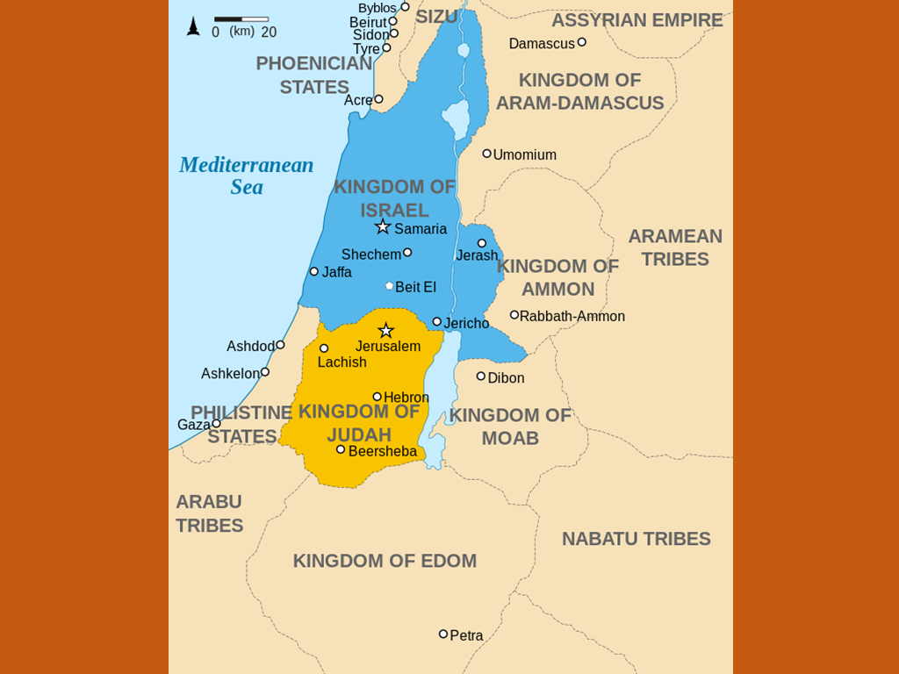

The following lists arrange the minor prophets according to the destination of their prophecies:

MINOR PROPHETS, pg. 3
THE SOUTHERN THE NORTHERN
KINGDOM OF JUDAH KINGDOM OF ISRAEL

JOEL HOSEA
MICAH AMOS
HABAKKUK
ZEPHANIAH JONAH
HAGGAI NAHUM
ZECHARIAH
MALACHI OBADIAH

In some cases the names of the minor prophets have significance for their ministries.
The translation or interpretation of Hebrew names is not always precise, but these
are the approximate meanings of the names of the minor prophets.

Hosea Salvation, Deliverance
Joel Yahweh is God
Amos Burden Bearer
Obadiah Servant of Yahweh
Jonah Dove (see Gen. 8:8)
Micah He Who Is Like Yahweh
Nahum Comforter
Habakkuk Embrace
Zephaniah The Lord Has Hidden
Haggai Festive
Zechariah Yahweh Remembers
Malachi My Messenger

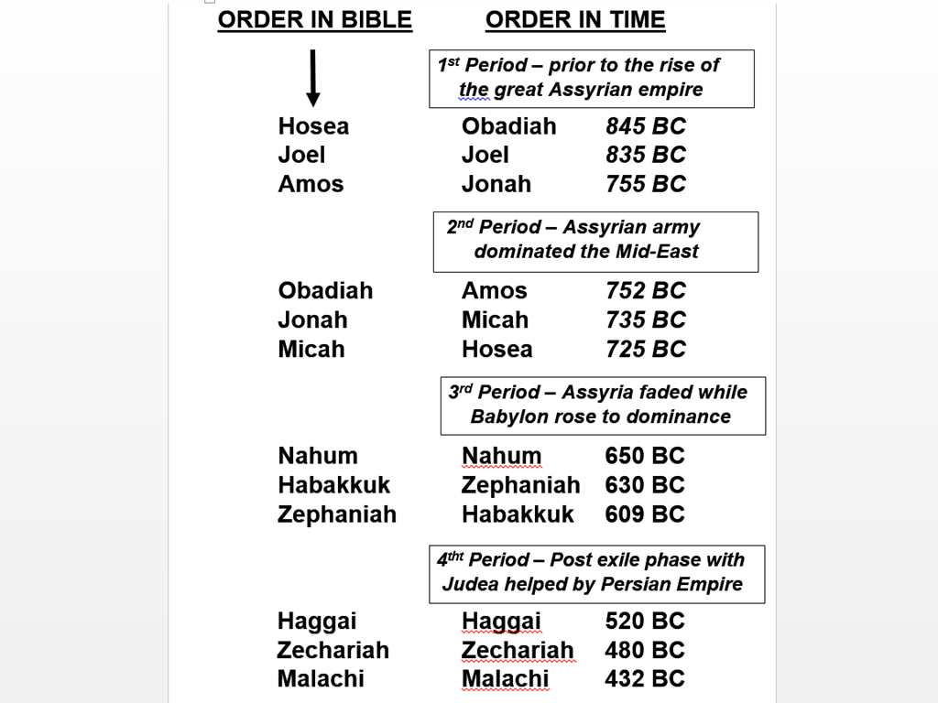

ASSYRIAA

EDOM

MINOR PROPHETS, pg. 4
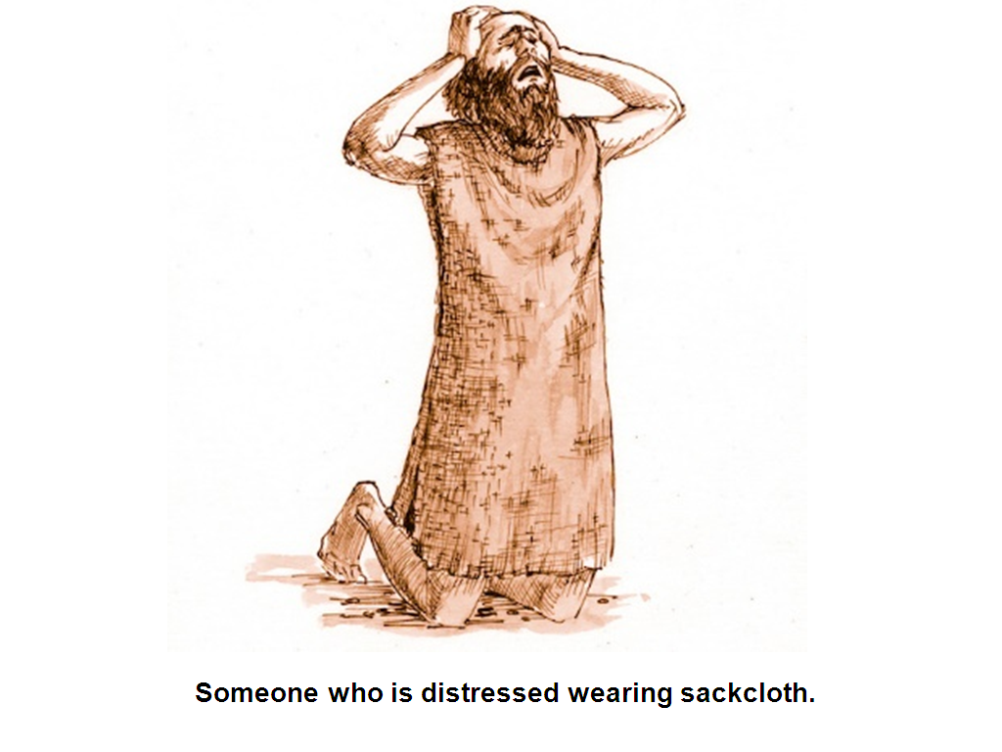

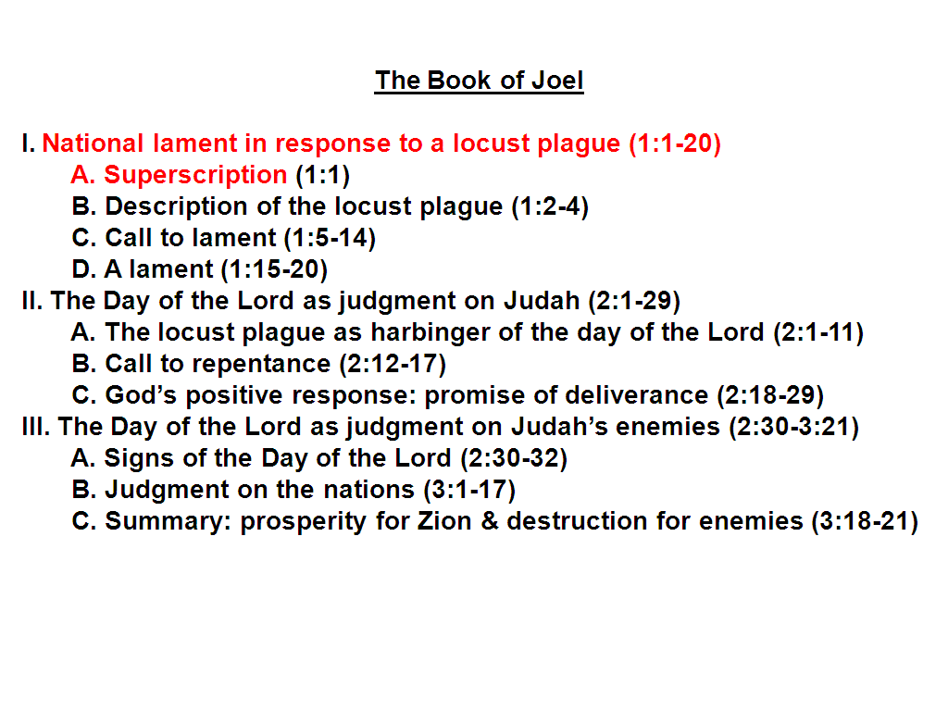

MINOR PROPHETS, pg. 5
MINOR PROPHETS #2: JOEL (7-27-14)

INTRODUCTION

Time frame: We are not certain of the exact period at which Joel prophesied, but he is generally believed to have been the earliest prophetic writer of the southern kingdom. Joel wrote sometime after Elijah’s ministry on Mt. Carmel and Jezebel’s death, but before King Nebuchadnezzer’s reign in Babylon. So he lived at the end of Atheliah’s reign (the worst Hebrew queen EVER who was Queen Jezebel’s daughter, 840-835 BC), and this period of time extended into the beginning of Joash’s reign (835 -796 BC) in Judah. Jehu was ruling in Israel (841-814 BC) at the time, and Shalmaneser III reigned in Assyria (841 BC).

The Book: Joel is fairly short, consisting of 3 chapters. It is a book of dreadful devastation and suffering and also of encouragement and hope. It has much to say about an invasion of locusts as judgment for the sins of the people which is also prophetic of a future judgment yet to come, “the Day of the Lord”, which is also a major theme in this book.

“This book depicts a locust plague that is perceived as the onset of the Day of the Lord, and narrates the future fortunes of Israel and the other nations. The Hebrew text contains four chapters, but chapters two and three are combined in most English editions, following the Septuagint (LXX) and the Vulgate.” Harper’s Bible Dictionary

The name Joel: Joel is a common name in the Hebrew Bible, meaning ‘Yah [weh] is God,’ the inverse form of the name Elijah. Joel is thus a polemical name, proclaiming that Yahweh, and not another party, is God. There are at least 14 men in the OT with his name.

The tetragrammaton (occurs about 6,800 times), usually pronounced “Yahweh”. “Adonai” in Hebrew means “My Great Lord”, said in place of the tetragrammaton YHWH that was considered to be too sacred to verbalize. Also, “Jehovah” is another replacement name used by some.

In Exodus 3:14, Moses asked God what he should tell the Egyptians when they asked him what God’s name was, and God answered “I Am That I Am”. The “I Am” is the sacred tetragrammaton. YHWH.

Exodus 6:2-3 God spoke further to Moses and said to him, "I am the LORD; 3) and I appeared to Abraham, Isaac, and Jacob, as God Almighty, but by My name, LORD, I did not make Myself known to them.

Joel 1:1 The word of the LORD that came to Joel, the son of Pethuel.

“The phrase ’word of the Lord’ commonly introduces prophetic books, Jer 1:2; Ezek 1:3; Hos 1:1; Jonah 1:1; Mic 1:1; Zech 1:1. Its frequency, however, should not numb us to its significance. It implies first that the message is from God and therefore carries divine authority. But its presence also reminds us that we are here dealing with a specific type of literature—Hebrew prophecy.” The New American Commentary

Joel is said to be the son of Pethuel which rules him out as being Joab or the son of Samuel. He was an otherwise unknown man was lifted up by the Lord to deliver a prophetic word to Jerusalem. Some say that Pethuel’s name means “the sincerity of God,” or “godly simplicity” while others say it means “the vision of God”.

Joel 1:2 Hear this, O elders, and listen, all inhabitants of the land. Has anything like this happened in your days or in your fathers' days?

Joel calls everyone to consider the uniqueness and significance of the disaster of the plague of locusts which had come on them.

MINOR PROPHETS, pg. 6
The elders were civil leaders who played a prominent part in the governmental and judicial systems, 1 Sam. 30:26-31; 2 Sam. 19:11-15.

Of course, his rhetorical question would get an emphatic NO for an answer. He was asking, “Has any calamity so grievous as this ever happened to Israel before? No such massive locust attacks had occurred since the ones God brought down on Egypt.

Joel 1:3 Tell your sons about it, and let your sons tell their sons, and their sons the next generation.

It was extremely important that the message of the locust plague be passed down to future generations so that they would learn from their ancestor’s mistakes and would fear God and obey Him in order to avoid a similar punishment.

A terrible locust plague apparently precipitated Joel’s prophecy. Out of this event, which Joel saw as no less than an act of God and a manifestation of the day of the Lord, the book develops a theological program that both interprets the disaster for the prophet’s generation and looks ahead to the end of the age. In the process the text shows that the “day of the Lord” is both judgment and salvation and that it appears in diverse historical events.

Joel began his message with the locust plague. His message might be summarized as follows: “What you have seen in the locusts is the day of the Lord that you have often heard the prophets foretell. It has begun not with the Gentiles but with us, the chosen people. We must realize that we are not exempt from judgment, and we must repent.” Later in the book Joel will show his audience that God has not abandoned his people and that the future also holds.

MINOR PROPHETS: JOEL #3 (8-3-14)

Joel 1:4 What the gnawing locust has left, the swarming locust has eaten; and what the swarming locust has left, the creeping locust has eaten; and what the creeping locust has left, the stripping locust has eaten.

LOCUSTS

Some believe that this verse describes four of over 80 species of locusts, however it is more likely that the terms are used to emphasize the successive “waves” of a locust invasion that usually comes fast, furious, and unexpectedly.

Proverbs 30:27 The locusts have no king, yet all of them go out in ranks.

- Gnawing locusts do heavy damage like army artillery to thin out the thick vegetation.
- Swarming locusts fly in like planes and dropping bombs to do more damage. infantry
- Creeping locusts move in like infantry to get anything green that’s left.
- Stripping locusts are the mop-up crew moving in last to get any stem or twig that is left.

This locust plague that has come with its four bands of locusts reminds us of the four horsemen of the Apocalypse who will ride in the Tribulation Period, Rev. 6:1-8.

Leviticus 11:20 All the winged insects that walk on all fours are detestable to you. 21) ‘Yet these you may eat among all the winged insects which walk on all fours: those which have above their feet jointed legs with which to jump on the earth. 22) ‘These of them you may eat: the locust in its kinds, and the devastating locust in its kinds, and the cricket in its kinds, and the grasshopper in its kinds. 23) ‘But all other winged insects which are four-footed are detestable to you. 24) ‘By these, moreover, you will be made unclean: whoever touches their carcasses becomes unclean until evening.

Flying insects were also detestable and hence could not be a food source for the Israelite, 11:20.

MINOR PROPHETS, pg. 7
Exceptions to the rule were insects that had jointed legs for hopping. These included the locust, katydid, cricket, and grasshopper, 11:21-22.

The reasons for this distinction are not clear, and it may be remembered that locusts were the diet of John the Baptist in the wilderness, Matt 3:4; Mark 1:6. The New American Commentary

There are ten Hebrew words used in Scripture to signify “locust”. By the Mosaic law, they were reckoned “clean” so that they could lawfully eat them. Their name also occurs in Rev. 9:3, 7 in allusion to this devastating insect that originated in the Orient.

“Locusts belong to the class of Orthoptera, i.e., straight-winged. They are of many species. The ordinary Syrian locust resembles the grasshopper, but is larger and more destructive. ‘The legs and thighs of these insects are so powerful that they can leap to a height of two hundred times the length of their bodies. (A 3” locus could leap 50ft.) When so raised, they spread their wings and fly so close together as to appear like one compact moving mass.’ Locusts are prepared as food in various ways. Sometimes they are pounded, and then mixed with flour and water, and baked into cakes; ‘sometimes boiled, roasted, or stewed in butter, and then eaten’.”
Easton’s Bible Dictionary

The devastations they have made in Eastern lands have been very appalling. The invasions of locusts are the heaviest calamites that can befall a country. “Their numbers exceed computation”: the Hebrews called them “the countless”, and the Arabs knew them as “the darkeners of the sun”. Unable to guide their own flight, though capable of crossing large spaces, they are at the mercy of the wind, which bears them as blind instruments of Providence to the doomed region given over to them for the time. Innumerable as the drops of water or the sands of the seashore, their flight obscures the sun and casts a thick shadow on the earth.

Ex.10:14-15 The locusts came up over all the land of Egypt and settled in all the territory of Egypt; they were very numerous. There had never been so many locusts, nor would there be so many again. 15) For they covered the surface of the whole land, so that the land was darkened; and they ate every plant of the land and all the fruit of the trees that the hail had left. Thus nothing green was left on tree or plant of the field through all the land of Egypt.

Judges 6:5 For they (Midianites and Amalekites) would come up with their livestock and their tents, they would come in like locusts for number, both they and their camels were innumerable; and they came into the land to devastate it.

Judges 7:12 Now the Midianites and the Amalekites and all the sons of the east were lying in the valley as numerous as locusts; and their camels were without number, as numerous as the sand on the seashore.

“It seems indeed as if a great aerial mountain, many miles in breadth, were advancing with a slow, un-resting progress. Woe to the countries beneath them if the wind fall and let them alight! They descend unnumbered as flakes of snow and hide the ground. It may be ‘like the garden of Eden before them, but behind them is a desolate wilderness. At their approach the people are in anguish; all faces lose their color’ (Joel 2:6). No walls can stop them; no ditches arrest them; fires kindled in their path are forthwith extinguished by the myriads of their dead, and the countless armies march on (Joel 2:8, 9). If a door or a window be open, they enter and destroy everything of wood in the house. Every terrace, court, and inner chamber is filled with them in a moment.

“Such an awful visitation swept over Egypt (Ex. 10:1–19), consuming before it every green thing, and stripping the trees, till the land was bared of all signs of vegetation. A strong north-west wind from the Mediterranean swept the locusts into the Red Sea.”
Easten’s Bible Dictionary

MINOR PROPHETS, pg. 8
Joel 1:5 Awake, drunkards, and weep; and wail, all you wine drinkers, on account of the sweet wine That is cut off from your mouth.

Drunkards were told to weep and wail because no wine would be available due to the destruction of the vineyards.

Joel 1:6 For a nation has invaded my land, mighty and without number; Its teeth are the teeth of a lion, and it has the fangs of a lioness.

The great swarm of locusts were like a mighty nation and innumerable (without number) that had invaded the prophet’s land. Their ability to devour was like that of a lion, which can rip and tear almost anything with its powerful teeth likened to fangs.

Joel 1:7 It has made my vine a waste And my fig tree splinters. It has stripped them bare and cast them away; their branches have become white.

The locusts had destroyed the vines and stripped even the bark from the fig trees leaving their branches white.

Joel 1:8 Wail like a virgin girded with sackcloth for the bridegroom of her youth.

The grammatical form of mourn in verse 8 (fem. sing.) indicates that the addressee is neither the drunkards in verse 5 nor the farmers in verse 11, both of which are addressed with masc. pl. forms. The land itself, 2:18, or Jerusalem, called Zion in 2:1, 15, 23, 32, is probably addressed here, being personified as a virgin or young woman, 2 Kings 19:21, “the virgin Daughter of Zion,” and Lam. 1:15 as “The virgin Daughter of Judah”, who was told to mourn bitterly, as a bride or bride-to-be would mourn in 2:1, 15, 23, 32, over the unexpected death of the man to whom she was betrothed or married.

Because of the legally binding nature of betrothal, Deut. 22:23–24 demonstrates that a betrothed woman could be referred to as both a “virgin” and a “wife.”

2 Kings 19:21 This is the word that the LORD has spoken against him: [Sennacherib, King of Assyria],'She has despised you and mocked you, The virgin daughter of Zion; She has shaken her head behind you, the daughter of Jerusalem!”

Sackcloth in v.13: a coarse cloth that was worn in mourning rites and in times of distress as an outward expression of sorrow, Gen. 37:34; 1 Kings 21:27; Neh. 9:1; Es. 4:1-4; Ps. 69:10-11; Isa. 22:12; 32:11; 37:1-2;Lam. 2:10; Dan. 9:3; Jonah 3:8. PP

Joel 1:9-10 The grain offering and the drink offering are cut off from the house of the LORD. The priests mourn, the ministers of the LORD. 10) The field is ruined, the land mourns; for the grain is ruined, the new wine dries up, Fresh oil fails.

The primary reason for mourning in this case was the plague’s negative effect on the formal worship system. It required flour and oil as well as wine for a drink offering.

Joel 1:11-12 Be ashamed, O farmers, Wail, O vinedressers, for the wheat and the barley; because the harvest of the field is destroyed. 12) The vine dries up and the fig tree fails; the pomegranate, the palm also, and the apple tree, all the trees of the field dry up. Indeed, rejoicing dries up from the sons of men.

So the farmers and the vine dressers had reason to be disturbed as well. Everything was dried up, even the rejoicing of men. PP pics

MINOR PROPHETS: JOEL #4 (8-10-14)

Joel 1:13-14 Gird yourselves, and lament, ye priests: howl, ye ministers of the altar:

MINOR PROPHETS, pg. 9
come, lie all night in sackcloth, ye ministers of my God: for the meat offering and the drink offering is withholden from the house of your God. 14) Sanctify ye a fast, call a solemn assembly, gather the elders and all the inhabitants of the land into the house of the LORD your God, and cry unto the LORD.

The disaster demolished the high dignity of the priesthood. They were to remove the white garments of the priesthood in favor of the black, coarse sackcloth and reduce themselves to wailing and a vigil of mourning instead of singing.

Why is God telling His people, “I want you to lament. I want you in sackcloth and ashes. I want you to mourn”? Before He had told them, “I want you to come before Me with joy.”

Psalm 95:2 Let us come before his presence with thanksgiving, and make a joyful noise unto him with psalms.

Psalm 100:4 Enter His gates with thanksgiving and His courts with praise. Give thanks to Him, bless His name.

The reason is because of sin in the nation.

14) Consecrate a fast, proclaim a solemn assembly; Gather the elders and all the inhabitants of the land to the house of the LORD your God, and cry out to the LORD.

Consecrate a fast:

“God had never asked them to do that before. God had given them feast days—He never gave them a fast day until they plunged into sin. The one sin Joel mentions which was destroying the nation was drunkenness. It was robbing people of their normal thinking; they were not able to make right judgments.” J. Vernon McGee, Thru the Bible Commentary, vol. 3

Fasting was often associated with repentance, 1 Sam. 7:6; Neh. 9:1-2; Jonah 3:5.
Times of great trouble drive people to God. You may remember how church attendance swelled after 911.

Cry out to the LORD… Why? Because God is merciful, He is gracious. He wants to forgive us. Our God is a wonderful God. They were to come to Him in this time of difficulty, and He would hear and answer their prayers. This was a fulfillment of Solomon’s prayer of consecration for the temple; they went to “the house of the LORD” to express their repentance.

Read: 1 Kgs 8:37-40

Joel 1:15 Alas for the day! For the day of the LORD is near, and it will come as destruction from the Almighty.

Similar passage:
Isaiah 13:6 Wail, for the day of the LORD is near! It will come as destruction from the Almighty.

Isaiah 13:9 Behold, the day of the LORD is coming, Cruel, with fury and burning anger, To make the land a desolation; And He will exterminate its sinners from it.

Ezekiel 30:3 For the day is near, Even the day of the LORD is near; It will be a day of clouds, A time of doom for the nations.

This verse speaks of the day of the Lord as “near,” although it is clear from this chapter that the locust plague had already occurred so it has to be speaking of a future event.

“The day of the Lord” is mentioned in Joel again in Joel 2:1, 11, 3:14. It is mentioned 13 times in the OT and 4 times in the NT.

MINOR PROPHETS, pg. 10
We will address “the day of the Lord” in detail when we get to chapter 2 verse 1.
Verses 16-0 contain a detailed description of the aftermath of the locust plague.

Joel 1:16-20 Has not food been cut off before our eyes, gladness and joy from the house of our God? 17) The seeds shrivel under their clods; the storehouses are desolate, the barns are torn down, for the grain is dried up. 18) How the beasts groan! The herds of cattle wander aimlessly because there is no pasture for them; even the flocks of sheep suffer. 19) To You, O LORD, I cry; for fire has devoured the pastures of the wilderness and the flame has burned up all the trees of the field. 20) Even the beasts of the field pant for You; for the water brooks are dried up and fire has devoured the pastures of the wilderness.

It is always sad when innocent animals suffer because of the stupidity and arrogance of man.
Dramatically and unexpectedly, we find that the scene has shifted entirely at 2:1. Instead of a call for lamentation over a locust plague that has already occurred and a drought that has already done its damage, the people of Jerusalem are called to arms to face a new threat that is about to bear down upon their walls.

MINOR PROPHETS: JOEL #5 (8-17-14)

Joel 2:1 Blow the trumpet in Zion, and sound an alarm in My holy mountain! Let all the inhabitants of the land tremble; for the day of the LORD is coming, for it is at hand.

The trumpet, ŠÔP̱ĀR, was a ram’s horn, blown by a watchman to alert the people of great danger

Read: Ezek. 33:1–6

My holy mountain! refers to the Temple Mount. The response to the blast of the trumpet was to tremble because something ominous and menacing which was of great concern was at hand.

Amos 3:6-7 If a trumpet is blown in a city will not the people tremble? If a calamity occurs in a city has not the LORD done it? 7) Surely the Lord GOD does nothing unless He reveals His secret counsel To His servants the prophets.

It was referring to the day do the Lord. Verse 11 says,“the day of the Lord is indeed great and very awesome.”This surely cannot refer to another locust attack for there is nothing left for them to eat. This is a new and much greater threat than the plague of locusts.

Joel 2:2 A day of darkness and gloom, A day of clouds and thick darkness. As the dawn is spread over the mountains, so there is a great and mighty people; There has never been anything like it, Nor will there be again after it to the years of many generations.

A more detailed description is given in:

Zephaniah 1:15 A day of wrath is that day, A day of trouble and distress, A day of destruction and desolation, A day of darkness and gloom, A day of clouds and thick darkness,

Ezekiel 30:3 For the day is near, even the day of the LORD is near; it will be a day of clouds, a time of doom for the nations.

Some believe that the great and mighty people that will envelope the land refers to the Assyrians in 701 BC or to the Babylonians in 605 BC but since this verse is describing what will take place in the Tribulation it seems to be more likely that it describing a demon army found in Rev. 9:1-12.

MINOR PROPHETS: JOEL #6 (8-24-14)

Joel 2:3 A fire consumes before them and behind them a flame burns. The land is like the Garden of Eden before them but a desolate wilderness behind them, and nothing at all escapes them.

MINOR PROPHETS, pg. 11
Isaiah 9:19 By the fury of the LORD of hosts the land is burned up, And the people are like
fuel for the fire; No man spares his brother.

Joel uses a simile, “the land is like the Garden of Eden”, to compare it to the destructiveness of this army when after it attacks.

Joel 2:4 Their appearance is like the appearance of horses; And like war horses, so they run.

Notice how this compares to the demon army in Rev. 9:7:
Revelation 9:7 The appearance of the locusts was like horses prepared for battle; and on their heads appeared to be crowns like gold, and their faces were like the faces of men.

Joel 2:5 With a noise as of chariots, they leap on the tops of the mountains, Llke the crackling of a flame of fire consuming the stubble, like a mighty people arranged for battle.

Revelation 9:9 They had breastplates like breastplates of iron; and the sound of their wings was like the sound of chariots, of many horses rushing to battle.

Joel 2:6-8 Before them the people are in anguish; All faces turn pale.7)They run like mighty men, They climb the wall like soldiers; And they each march in line, Nor do they deviate from their paths. 8) They do not crowd each other, they march everyone in his path; When they burst through the defenses, they do not break ranks.

Joel 2:9 They rush on the city, they run on the wall; they climb into the houses, they enter through the windows like a thief.

The language of these verses applies both to locusts and to a literal army. Both advance in orderly fashion.

Joel 2:10 Before them the earthquakes, The heavens tremble, The sun and the moon grow dark and the stars lose their brightness.

As in the convulsions of the sixth seal in Rev. 6, all that men have esteemed sure and stable will be overturned. It is the destruction, not of the material universe, but of the moral, spiritual and political economies.

Joel 2:11 The LORD utters His voice before His army; Surely His camp is very great, For strong is he who carries out His word. The day of the LORD is indeed great and very awesome, and who can endure it?

The presumed answer to the question is, “No one” that reminds us of the information given in:

Matt. 24:22 Unless those days had been cut short, no life would have been saved.
[If this time period went on indefinitely, no one would live through it.]

